INF Pullout Talking points

BACKGROUND
The 1987 Intermediate-Range Nuclear Forces (INF) Treaty was negotiated by Ronald Reagan and Mikhail Gorbachev. The INF required the United States and the Soviet Union to eliminate and permanently forswear all of their nuclear and conventional ground-launched ballistic and cruise missiles with ranges of 500 to 5,500 kilometers. The treaty marked the first time the superpowers had agreed to reduce their nuclear arsenals, eliminate an entire category of nuclear weapons, and utilize extensive on-site inspections for verification. As a result of the INF Treaty, the United States and the Soviet Union destroyed a total of 2,692 short-, medium-, and intermediate-range missiles by the treaty's implementation deadline of June 1, 1991.

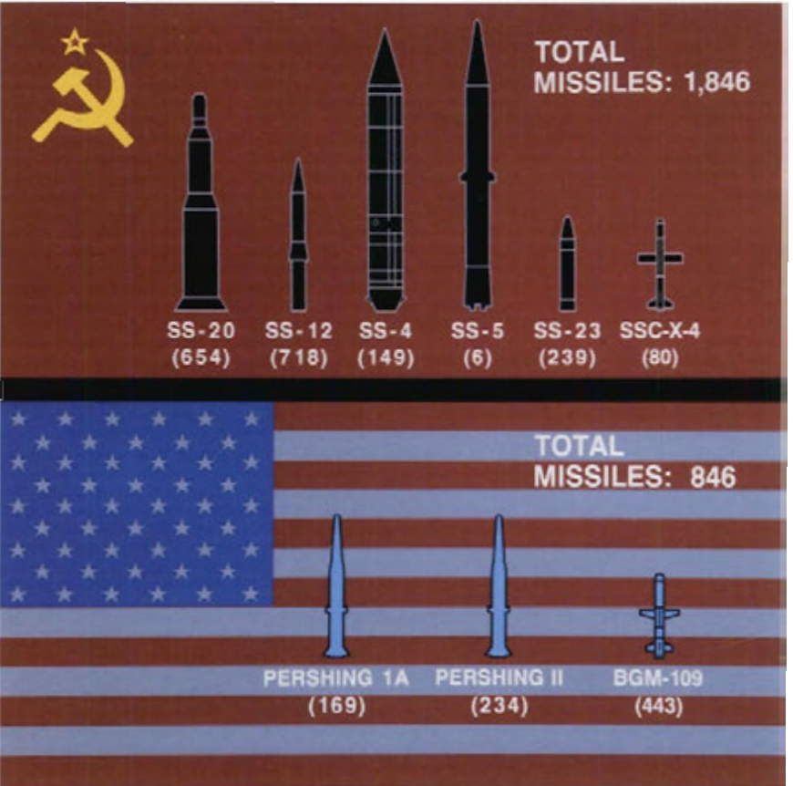
The US destroyed 846 of its missiles and 32 launch sites, and the USSR destroyed 1,846 missiles and 117 sites.

The two nations negotiated the INF even though the US claimed the Soviets were violating the Anti-Ballistic Missile Treaty (ABM). These good faith negotiations led to the breakthrough INF Treaty, the Soviet Union moving into full compliance with the ABM, and paved the way for the massive reductions of the first START. Gorbachev showed courageous leadership by agreeing to a deal that many saw as favoring the US.

In 2007, Russian president Vladimir Putin declared the treaty no longer served Russia's interests. In 2014, President Obama accused Russia of breaching the INF after it allegedly tested a ground-launched cruise missile. He reportedly chose not to withdraw from the treaty under pressure from European leaders, who said such a move could restart an arms race.

KEY MESSAGE:
Trump has fired the starting pistol on Cold War II. Only this one will be bigger, more dangerous, and the world may not be so lucky this time around.

European leaders, and especially NATO allies, must make it clear that the INF is a red line they will not cross. They should be working toward removing all nuclear weapons from European soil and joining the Treaty on the Prohibition of Nuclear Weapons.

By pulling out of the nuclear arms agreement with Russia, Donald Trump has plunged the world into an existential crisis it may not survive. He has put us back decades, to when the US and Russia could develop and grow their nuclear arsenals without any restraints.

This is an urgent clarion call to all other nations to sign the Treaty on the Prohibition of Nuclear Weapons right now — we need to pull the handbrake on this new nuclear arms race by supporting the TPNW.

Nuclear weapons are banned and violate international human rights and humanitarian law. Nations breaking treaties and seeking to develop more nuclear weapons are endangering us all with their commitment to security based on weapons of mass destruction.

The response of a strong leader in a situation like this is to build faith, not break it. Ronald Reagan negotiated the INF Treaty, even though Russia was in non compliance with the Anti-Ballistic Missile Treaty. The result was the INF, Russia complying with the ABM and negotiating further reductions with START.

The INF rescued Europe from one of the most dangerous escalations of the Cold War and set the US and Soviet Union on a path to remove thousands of nuclear weapons. Pulling out of the INF will move the world in reverse and endanger all Europeans.

TWEETS:

The Treaty on the Prohibition of Nuclear Weapons brings democracy to disarmament. With the US withdrawing from #INFtreaty. It’s more urgent than ever that all states take a stand by joining the #nuclearban

This is the moment for financial institutions to decide if they are on the side of humanity or if they will double-down on their investment in banned nuclear weapons. We need private sector leadership. Tell your bank #dontbankonthebomb

TOPLINE:

- The 1987 Intermediate-Range Nuclear Forces (INF) Treaty began the wind-down of the Cold War. For the first time the US and Soviet Union agreed to reduce their arsenals and commit to extensive on-site inspection.

- The Treaty built trust and set the stage for massive nuclear arms reductions. Tearing it up is tearing up trust and any chance for nuclear disarmament.

- There are no winners in a nuclear arms race. This is a massive own-goal by the US, and now frees up Russia to deploy nuclear missiles without any constraints or oversight.

- Trump is racing backwards to the most dangerous time in history. All the progress that has been made in the last few decades to walk the world back from the brink of destruction is being undone, and for no gain or benefit. It is a monumental mistake.

- This increases the urgency and importance for the Treaty on the Prohibition of Nuclear Weapons to become the instrument we all rally behind. It can prevent a new nuclear arms race and inject the sanity the rest of the world can bring to this risk-fueled disaster.

- Trump is making the US less safe, Europe less safe and the world less safe. 700 million Europeans will awaken this morning to very worrying news. Every EU state must now urgently sign the TPNW to counteract this development.

- We have to ask why would two sworn enemies and rivals sign this in the first place during the height of the Cold War - that’s how dangerous the situation had become, having Europe littered with nuclear missiles aimed at each other. Even the US and Soviet Union at the time knew how bad an idea that was. Now Trump has plunged the world back into it.

- We need to ask who benefits from this decision to make the world so much less safe? Look no further from the companies — many of whom donate to Donald Trump — who will cash in on the nuclear weapons windfall from a new arms race. Last year already saw an increase of $81bn invested in nuclear weapons alone — this will be a drop in the ocean now.

- Europe already hosts the majority of the world’s nuclear weapons. This development could see the continent littered with more and making Europe a nuclear tinder box.

- European banks must move to unwind their financial entanglements in nuclear weapons and make clear that they will not be party to a new arms race.

- China cannot join a treaty that doesn’t exist! If the US and Russia both want to see a reduction of these weapons by China, they should strengthen the INF, not blow it up.

Q’s:
What happens next?
Now Russia will have a free hand to develop and deploy whatever nuclear missiles they like, but now there will be no oversight or transparency.
The US has already signaled its intention to launch a new nuclear arms race

Hasn’t Russia violated?
The fact is we don’t know — they are also accusing the US of violating. We must exhaust all diplomatic options to resolve those questions rather than beginning the Cold War nuclear arms race as the first resort. We may not be so lucky this time around.

Isn’t this Russia’s fault?
Regardless of whose fault it is or who started it, pulling out of the INF is in nobody’s interest — and definitely not the US’s interest. We need to rise above petty name calling when the stakes are this high and do what is in everyone’s interest.

Is this about China/Aren’t the US’s hands tied re China in Pacific?
No. That’s not true. The vice-chairman of the Joint Chiefs of Staff said the US can already use air- and sea-based missiles for those targets, and leaving the INF is unnecessary to combat China.

Shouldn’t China join the INF Treaty?
China can’t join a treaty that doesn’t exist! Nobody should support a build up of these nuclear weapons by China, the US, Russia, or any state, but Trump’s unilateral move will kick a new arms race into high gear and do nothing to reduce China’s arsenal. It will have the opposite effect.

UK Support
If the UK really cared about Russia complying, like it says, it would never back the US pulling out of the only treaty currently setting the terms for their compliance. By lining up behind Donald Trump, the UK is now giving Russia a carte blanche to build these missiles. The UK is now less safe.

